Delta Kappa Gamma Society International



Alpha Epsilon State

Alpha Psi Chapter

Fort Wayne, Indiana

May 10, 2015 Nancy Sprague Issue 3

4327 Indiana Avenue

Fort Wayne, Indiana 46807

260-745-7698

[njsprague@msn.com](mailto:nancy.sprague@fwcs.k12.in.us)

*­­­­­­­­­­­­­­­­­­­­­­­­­­­Delta Kappa Gamma…promotes professional and personal growth*

*of women educators and excellence in education*.

**June Meeting**

## 

**Saturday, June 4**

**11:00 AM**

**Boathouse Restaurant**

**700 Park Avenue**



##### Winona Lake

##### Phone (574) 268-2179

##### Hostess: Carol Buttell

##### 

*MAKE RESERVATIONS WITH Carol by* ***May 15***

*Phone 489-5413 or email* [*cbuttell@frontier.com*](mailto:cbuttell@frontier.com)

**ABOUT THE BOATHOUSE**

Located in the Village at Winona in Historic Winona Lake, Indiana, The BoatHouse Restaurant was established in 2000. Prior to the BoatHouse Restaurant, The Winona Assembly built an original boathouse in 1895, which was used to store the nearly three hundred watercraft the Assembly had available for rent. In the 1940’s the original boathouse was removed and in its place was built a new cafeteria. The cafeteria was used by the Winona Lake Bible Conference until the 1960’s when it was converted into a roller skating rink. Today, the BoatHouse Restaurant is built on the same foundation as the old cafeteria and is designed as an architectural reminder of the original boathouse.

The BoatHouse Restaurant was established in 2000 basing our cuisine on fresh ingredients and homemade dishes. Throughout the years, we have strived to keep the same principles in place. Great efforts have been made by our chef to continue our vision to provide our guests with the freshest ingredients and great tasting dishes. Our experienced and knowledgeable staff is eager to provide you with an unparalleled dining experience overlooking the beautiful waters of Winona Lake. We look forward to hearing your feedback! Please feel free to tell us about your dining experience! October, 2010 marked our ten year anniversary and are looking forward to many more great years of serving our guests!

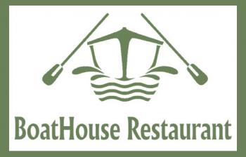

**\*\*\*\*\*\*\*\*\*\*\*\*\*\*\*\*\*\*\*\*\*\*\*\*\*\*\*\*\*\*\*\*\*\*\*\*\*\*\*\*\*\*\*\*\*\*\*\*\*\*\*\*\*\*\*\*\*\*\*\*\***

Treasurer's Report

4/30/2016

      Savings     $ 2239.29

      Checking       642.30

             Total  $ 2881.59

I have not sent IPFW a check yet.

Sharon Bertrand

Treasurer

**APRIL 13 MEETING**

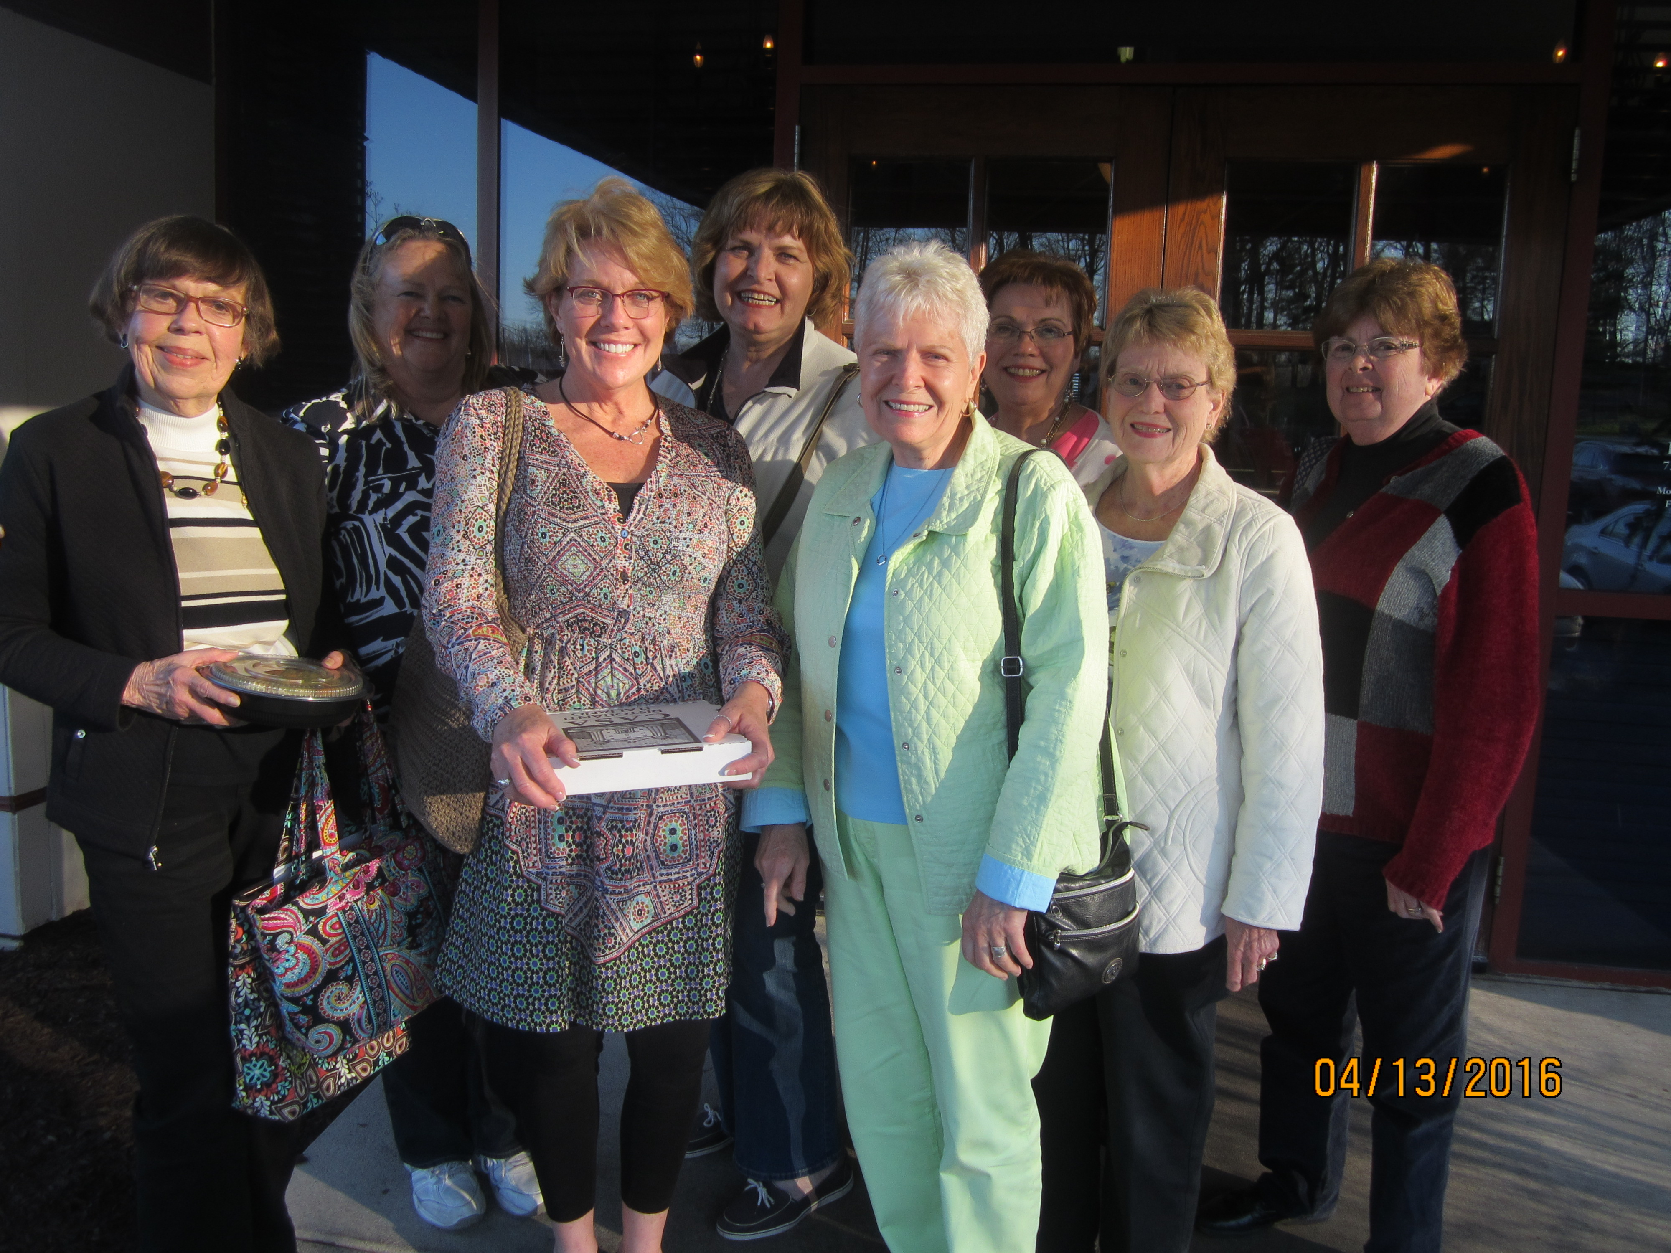

Members enjoyed a marvelous tour of McNamara Florists,

followed by dinner at Casa Restaurant.

DELTA KAPPA GAMMA, ALPHA PSI

MINUTES APRIL 13, 2016

Following a tour of McNamara Florists and receiving free baskets of pansies, Alpha Psi members drove to Casa Restaurant on West Jefferson Street for dinner and the meeting. President Carol Buttell opened the meeting by welcoming attendees and thanking Mary Jo Purvis for making arrangements. She thanked Nancy Sprague for sending the newsletter containing meeting information and for taking reservations.

Carol has arranged the next meeting on June 4, 11:00, at the Boat House Restaurant at Winona Lake. Following the meal and meeting, shopping may be done at the nearby shops. Carol will take reservations and they must be received by Monday, May 16. Call 260-489-5413 or e-mail cbuttell @frontier.com The trip takes about 45 minutes from Ft. Wayne and carpooling is suggested.

Carol gave the Cheer Committee report. Carol Terwilliger sent cards to Pat Doerr’s family upon her death and to Sondra Merganthal, who has been in the hospital and in rehab. Carol took a red rose to the funeral home at the time of calling for Pat and a rose to Sondra at rehab. Sondra asked Carol to tell everyone at the meeting “Hello and I really wanted to be here!” Carol passed a card for attendees to sign and to be sent to Sondra in Parkview Rehab.

Carol said that she would not be attending the State meeting in Terre Haute April 23. She passed a paper on which members could sign up to receive The Hoosier Newsette by e-mail. Thought needs to be given to supporting an International Project: Schools for Africa or Early Career Educators.

New officers need to be chosen for the next biennium. Carol will not be continuing as president. She thanked those who had served for the past two years, and stated that the meetings that they had arranged were good and much appreciated by members. She asked for members to volunteer to serve. Alpha Psi can continue to use the same plan of having a president (or contact person) to receive information from State and International. This person can conduct the meetings or the person who arranged the meeting can conduct it, telling any DKG information that has been sent to the president. She named the regular Alpha Psi Committees: President; Secretary; Treasurer/Finance; Membership; Educational Excellence/Program; Communication/Publicity/Newsletter. She stated that members could take a committee and arrange a meeting program that goes with that committee. The CCOT meetings for training for chapter officers and committee chairs will be held Saturday, June 18, in Lafayette and Thursday, June 23 in Bloomington. Chapters can decide which to attend. CAROL MUST HAVE A REPORT ON NEW OFFICERS AND COMMITTEE CHAIRS TO STATE BY MAY 15. She offered to help anyone.

*Carol Buttell, Ed.D,*

*Secretary*

