Alpha Alpha On-Line…
ALPHA ALPHA CHAPTER, PARKE & VERMILLION COUNTIES
ALPHA EPSILON STATE, INDIANA
THE DELTA KAPPA GAMMA SOCIETY INTERNATIONAL
May 11, 2016
Vol. 15, Number 5

MISSION STATEMENT
The Delta Kappa Gamma Society International promotes professional and personal growth of women educators and excellence in education.

PRESIDENT’S MESSAGE
May 11, 2016
Only 11 more days until school is out! The time is going fast! At this time of year students and teachers start to get a little restless and kind of annoying! Students are ready for baseball, vacations, and camp, and could hardly care about school. Teachers are panicked that they don’t have enough time to teach Mesoamerica and Histograms in two weeks. Ready or not-the summer break is here!
This past week, our school had Teacher Appreciation Week. We were treated royally by our PTO with a special lunch every day. Our principal even grilled steaks! I also received a couple of nice cards from former students. Those will go in my Teacher Treasure box. It was a good week to be a Teacher.
As I am hanging up my whistle this year and retiring, I have no doubts that I have the greatest profession in the world. I had the opportunity to touch a few lives and hopefully make a difference in some. I have enjoyed my thirty seven years of teaching and have felt blessed.
Surprisingly, I have no regrets about my decision to retire. I am excited for a new chapter in my life. I am not sure what that is, but God knows, and He will open doors for me.
We have 3 teachers retiring in our corporation this year. We are all at the top of the pay scale. I am hopeful that our remaining teachers will get a pay raise next year. I know they deserve it.
Today there is a national concern for a shortage of teachers. We all know why. In spite of all the discouragement in education, I personally know five young women who are studying to be teachers. Each one of them will be excellent educators. The love of children and the gift of teaching will prevail over obstacles in the State and National Departments of Education.
Not only am I hanging up my whistle, but I will also be handing over the gavel this month to our new President, Anita Osella. I am know that she will be a wonderful leader for our chapter! I think Alpha Alpha is an outstanding organization, and that we are one of the strongest chapters in the State of Indiana. I know that you will give her the support that you have given me these past two years.
I would like to thank all of my officers, committee chairmen, and fellow sisters who have helped to make my biennium run smoothly and successfully. I enjoyed serving as your President.
Thanks for everything!
Love,
Sue

April Minutes
Delta Kappa Gamma Society International
Thursday, April 7, 2016
The Alpha Alpha Chapter of Delta Kappa Gamma Society International met on Thursday, April 7, 2016 at the Bloomingdale Friends Church in Bloomingdale, Indiana at 6:00 p.m. with twenty-three members and five guests attending.
The meeting was hosted by Area 5. Kathy Jones welcomed everyone. Sarabeth Marcinko offered the invocation. A delicious dinner was enjoyed by the group.
Sande Bemis introduced Tim Skinner, candidate for Indiana State Representative, who spoke about his concerns for the future of education in Indiana.
The guest speakers were Susan and Curtis McVey, who shared pictures and interesting stories about their Harvest Mission Trip to St. Kitt.
The meeting was called to order by First Vice President, Anita Osella.
Minutes of the last meeting were included in the newsletter. Anna Ringwald made a motion to accept the minutes as written and Sarah Sykes seconded the motion. Motion passed.
Treasurer Anna Ringwald reported a balance of $2,388.61 in the treasury. A free will offering was taken for the South Vermillion Art Show.
Correspondence secretary, Gale Overbey shared Thank You notes from Art Show winners Wayne Nicholas, Cheyenne Tects, Holly Buchanan, and Noelanie Loomis.
Sarabeth Marcinko and Sarah Sykes gave updated information on the Indiana State Conference coming up on April 23 at the Sycamore Banquet Center in Terre Haute, Indiana. They reported that one hundred twenty-two members were presently registered for the conference. A reminder was made for volunteers to stuff goodie bags for the Conference to meet on Tuesday, April 19 at 5:00 p.m. at Dailey Chapel Christian Church.
Anita Osella thanked everyone for helping with snacks for the staff at each of the area schools during the ISTEP testing weeks.
Jan Palmateer, chairman of the Nominations Committee and committee members Teresa Adams, Elaine Albers, Gwen Hinshaw, and Catherine Weeks presented their slate of officers for 2016-2017.

President: Anita Osella
First Vice President: Addy Gideon
Second Vice President: Sue Woodard
Recording Secretary: Cheryl Huey
Corresponding Secretary: Gale Overbey
A motion was made by Janice Cole and seconded by Jacquie Mack to accept the slate of officers. Motion passed.
Teresa Adams made a proposal to have member initiations only one per year. After some discussion, the proposal was sent to the Planning Committee for further review.
Janice Cole spoke about the $500 Audry Wood Grant-in-Aid applications and encouraged members to recommend applicants who are a junior in college and enrolled in the Department of Education.
At the May 14 meeting, a memorial will be held for June Rendaci. If you have anything to share, please contact Sandee Frey prior to the meeting.
Jan Palmateer invited everyone to the next meeting on Saturday, May 14, 2016 at 9:30 a.m. at the Clinton First United Methodist Church in Clinton, Indiana. A Founders’ Day Program, Memorial Service, and Installation of Officer will be held at this meeting.
A motion was made by Sue Woodard and seconded by Maggie Stockwell to adjourn the meeting. Motion carried.
Respectfully submitted,
Cheryl Huey
Recording Secretary

Come to our May Meeting!
Our final meeting of the year will be Saturday, May 14, at 9:30 a.m. We will be initiating Angie Lewis. There will also be installation of officers. We will meet upstairs at the First United Methodist Church for the initiation and memorial Service. Lunch will follow in the basement served by the Esther’s Circle. Our State Liaison, Faye Peter, will be visiting that day. It will be hosted by Area 2. Everyone is welcome!

Alpha Epsilon Spring Conference Was a Success!
A big thank you goes to Sarabeth Marcinko and Sarah Sykes for Co-Hosting the State Spring Conference on Saturday, April 23 at the Sycamore Banquet Center on the Indiana State University Campus. Council 10 worked together to host the event. Our chapter was in charge of goodie bags. We also served as Presenters for the speakers and as Table Hostesses. Music was provided by the “Party of Five.” Mike Lunsford was the guest speaker for the luncheon. Alpha Alpha Chapter had fourteen member attend the conference.
We also had a poster on display to show the progress of our Strategic Planning in Action. Parke and Vermillion Counties were well represented by providing two programs, “Monarchs, Milkweeds, and More,” by Phil Cox and “WW II Correspondent Ernie Pyle,” by Joanie Rumple. It was a good day.

Committee Chairmen and Officer Training –CCOT

Mark your calendars to attend the Officer Training this summer. Our goal is to have five in attendance at either session:

Saturday, June 18
First Assembly of God
100 Back Lane
Lafayette, IN

Thursday, June 23
Sherwood Oaks Christian Church
2700 E Rogers Road
Bloomington, IN

Those that need to attend are President, First Vice-President, Secretary, Treasurer, Communications, and Membership Chairmen.

Registration Forms will be available at the meeting on Saturday.

News Around the Chapter

We are happy to report that Addy Gideon is successfully recuperating from her knee replacement. She is currently having some physical therapy. She got rid of her walker a couple days after her procedure and is now back to enjoying family ball game and events.

Jacquie Mack’s granddaughter Skyler, who was born January 31 at 1lb and 10 oz. She got to come home for Mother’s Day. Grandma Jacquie is beaming with happiness!

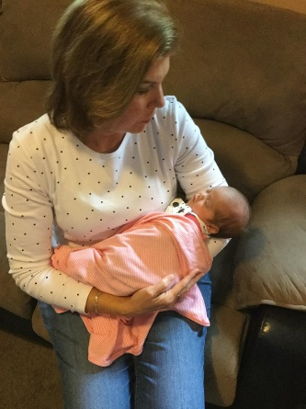
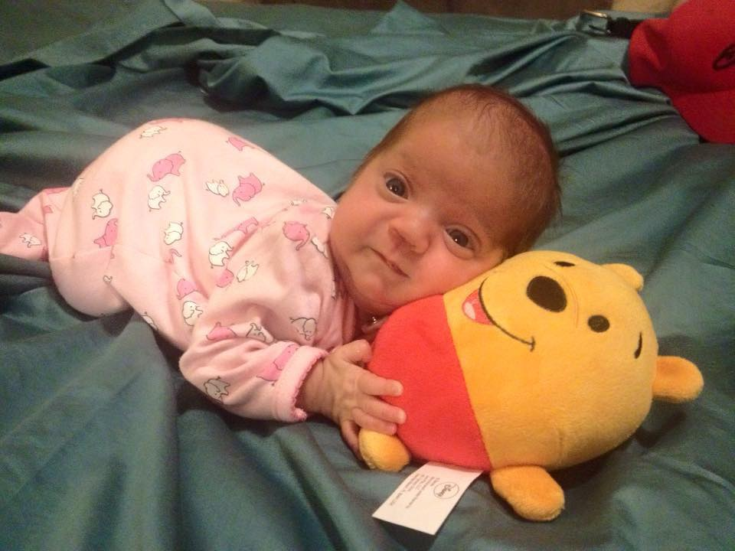

Newsletter Editor:
Sue Weber
249 S Jackson St
Clinton, IN
765-832-7879 home
812-239-2519 cell
sue.weber@sbcglobal.net
sweber@nvc.k12.in.us

Upcoming Events

CCOT- Saturday, June 18
First Assembly of God
100 Back Lane
Lafayette, IN

Thursday, June 23
Sherwood Oaks Christian Church
2700 E Rogers Road
Bloomington, IN

International Convention-Nashville TN
July 5-9, 2017
Gaylord Opryland Hotel

2017 State Convention
April 28-30, 2017
Lexington Hotel
Indianapolis, IN

Purposes
- To unite women educators of the world in a genuine spiritual fellowship.
- To honor women who have given or who evidence a potential for distinctive service in any field of education.
- To advance the professional interest and position of women in education.
- To initiate, endorse and support desirable legislation or other suitable endeavors in the interests of education and of women educators.
- To endow scholarships to aid outstanding women educators in pursuing graduate study and to grant fellowships to non-member women educators.
- To stimulate the personal and professional growth of members and to encourage their participation in appropriate programs of action.
- To inform the members of current economic, social, political and educational issues so that they may participate effectively in a world society.

