Who are we?

Mu Chapter is a group of key women educators in Rock Island and Mercer Counties in Illinois. We are part of a much larger group, The Delta Kappa Gamma Society International.

What do we do?


We meet 6-7 times during the year to further the personal and professional growth of our members, and to have fun! We also are involved in projects for our members and in the community.

Who can be a member?

If you are a woman with a job in education (teacher, librarian, education director, educational administrator, etc.) you can be recommended by one of our members for membership. Come check us out and introduce yourself!

Mission Statement

The Delta Kappa Gamma Society International promotes professional and personal growth of women educators and excellence in education.

Mu Chapter
Programs 2011-2012

September 27
The Razzle-Dazzle of Interactive White Boards
October 27
Finding Success With Writing – Yours or Your Students’
December 8
‘Make-It, Take-It Greeting Cards
February 7
Valentine Appetizers
March 13
Dress for Success
April 16
Organic Gardening and Lawn Care
June 13
Field trip to Miss Effie’s Flower Farm and Garden Stuff

How can I find out more?

Contact our Membership Chair
at:

Visit our website at:

Visit one of our meetings – we would love to meet you!

Visit the international and state websites of The Delta Kappa Gamma Society International:
www.dkg.org
www.deltakappagamma.org/IL

(Consider also including a section on scholarship or grants available through different levels of the Society.)

Our Projects

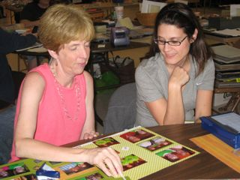
We held a scrapbooking day to raise funds for teacher grants to early career educators. What a great way to help our colleagues while having fun!

We gave eight $100 teacher grants to young teachers to use in their classrooms.

We then put together gift bags for them.

We partner with Blackhawk Reading Council to provide books to elementary school children.

Mu
Chapter

of The Delta Kappa Gamma Society International


Society Vision Statement

Leading women educators impacting education worldwide

